**Experiment No: 6**

**Home Automation using Cisco Packet Trace**

**Name:__________________________ Roll No._____________**

**Objectives**

**Part 1: Explore the Existing Smart Home Network**

## Part 2: Add Wired IoT Devices to the Smart Home Network

## Part 3: Add Wireless IoT Devices to the Smart Home Network

**Theory-**

We have studied a case study on Home Automation. Let us build a network for Home Automation using Packet Tracer.

In this Lab we will open a Packet Tracer file with an existing home network, explore the devices on the network, and then add additional wired and wireless IoT devices

**Packet Tracer – Adding IoT Devices**

**The Smart Home Network**

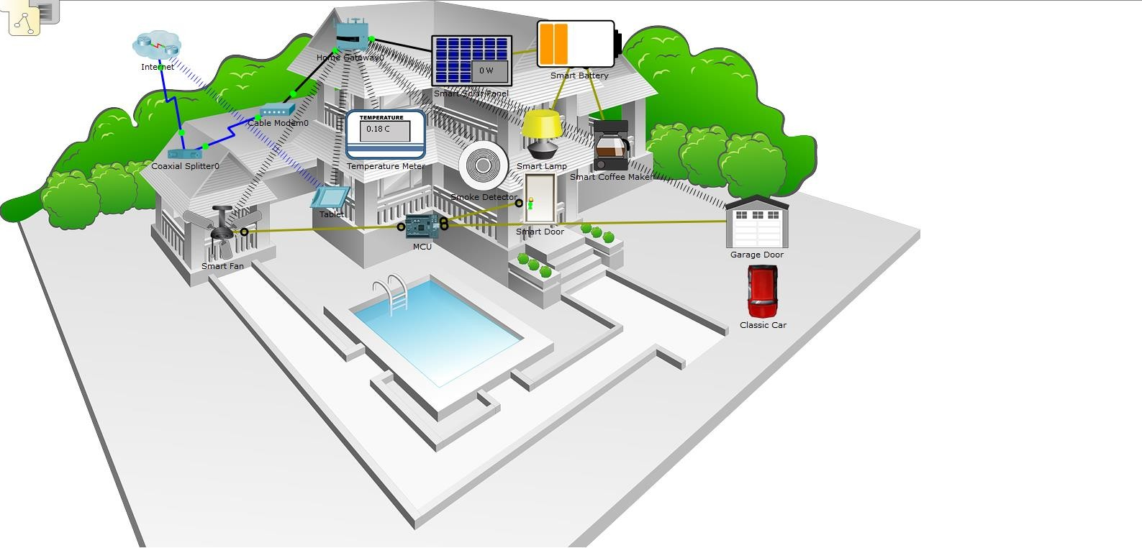

# Part 1: Explore the Existing Smart Home Network

## Step 1: Open the Smart_Home_Network.pkt file

* Open the **Smart_Home_Network.pkt** file.
* Save the file to your computer.

## Step 2: Explore the Smart Home Network

* Explore IoT end devices.

At the bottom left corner of the Packet Tracer window, locate and click the **End Devices** icon in the top row, and the **Home** icon in the bottom row of the **Device-Type Selection** box.

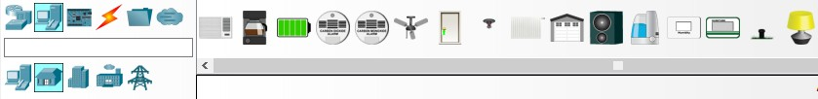

Across the bottom of the Packet Tracer window, the **Device-Specific Selection** box displays the many different Smart Home IoT devices available.

Move the mouse pointer over each device and notice that the descriptive name of the device is displayed at the bottom of the **Device-Specific Selection** box. Take a moment to look at each device type.

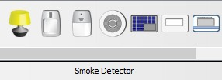

* Explore the Smart Home network.

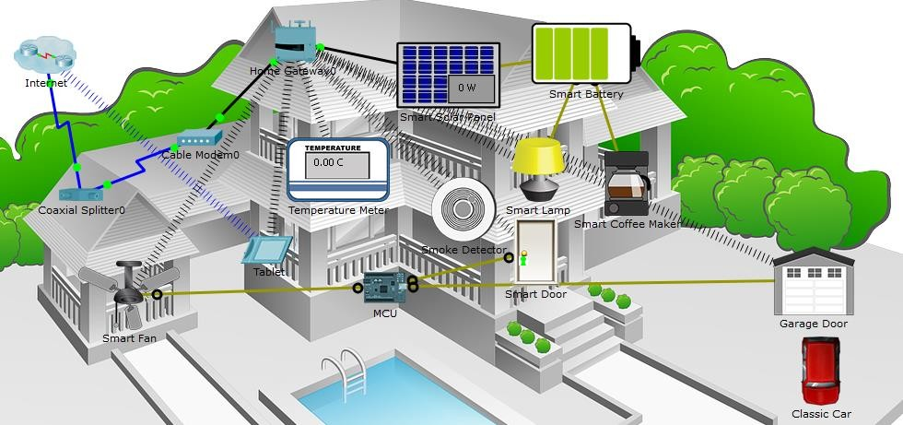

In the **Logical** workspace is a prebuilt smart home network that consists of many wired and wireless IoT devices, and network infrastructure devices.

When we place your curser over a device, such as the Smart Fan, an informational window opens containing basic network information about that device.

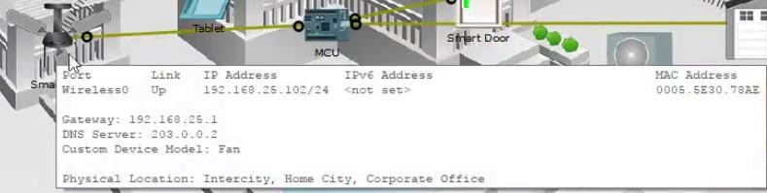

To turn on or activate a device, simply hold down the **Alt** key on the keyboard and then move the cursor over the device. Try this on each of the smart devices to observe what they do.

The smart home network also consists of infrastructure devices such as a home gateway. Click the **Home Gateway** icon to open the **Home Gateway** window.

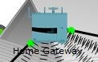

The **Physical** tab is selected by default and shows a picture of the Home Gateway.

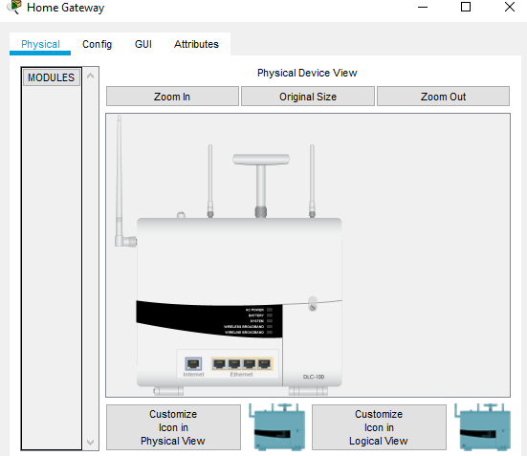

Next, click the **Config** tab and then in the left pane click **LAN** to view the LAN Settings of the Home Gateway.

Write down the IP Address of the home network for future reference.

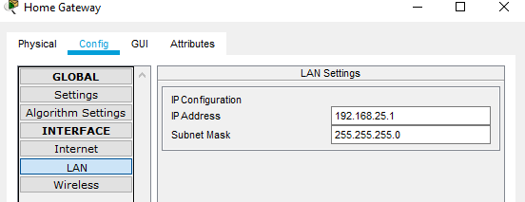

Click **Wireless** in the left pane to view the wireless settings of the Home Gateway.

Write down the SSID of the home network and the WPA2-PSK Pass Phrase

for future reference.

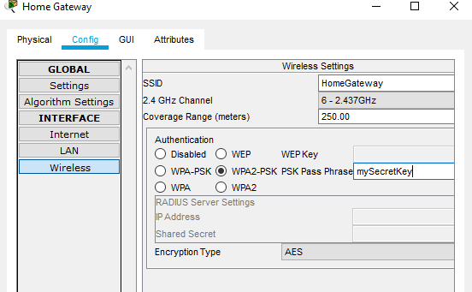

Close the **Home Gateway** window.

Next, click the **Tablet** device icon to open the **Tablet** window.

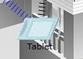

In the **Tablet** window, select the **Desktop** tab and then click the **Web Browser** icon.

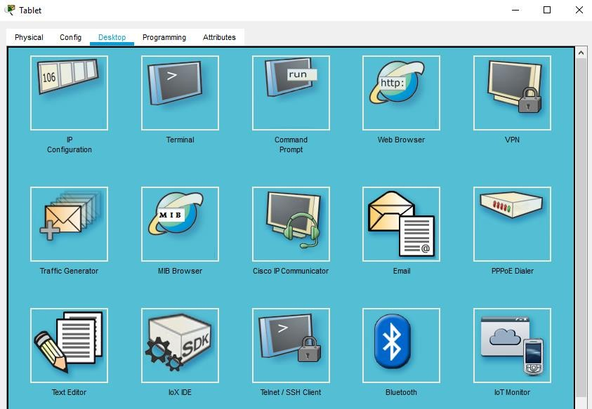

In the **Web Browser** window, type the IP address of the Home Gateway 192.168.25.1 into the URL box and click **Go**. In the **Home Gateway Login** screen, type admin for both the username and the password and click **Submit**.

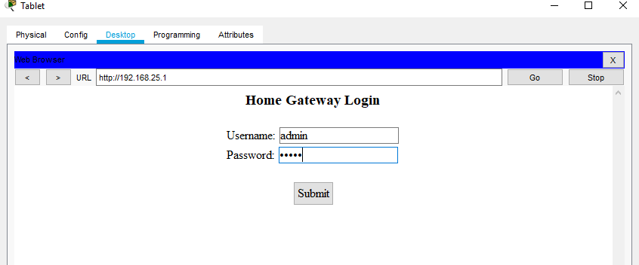

After you have connected to the Home Gateway web interface, a list of all the connected IoT devices appears.

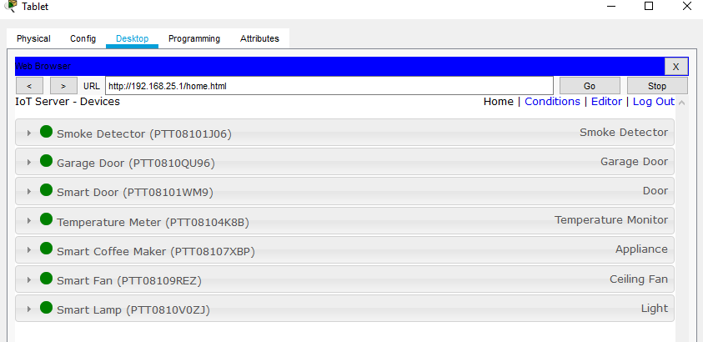

When you click a device in the list, the status and settings of that device is displayed.

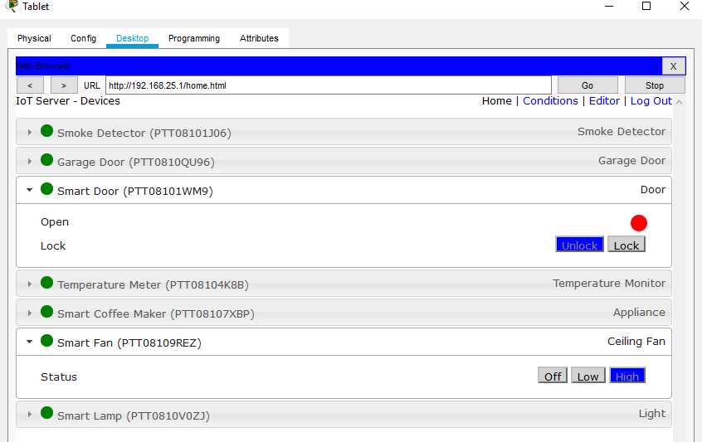

Close the **Tablet** window.

# Part 2: Add Wired IoT Devices to the Smart Home Network

## Step 1: Cable a device to the network

* In the **Device-Specific Selection** box, click the **Lawn Sprinkler** icon and then click in the workspace where you would like to locate the **Lawn Sprinkler**.
* Cable the Lawn Sprinkler to the Home Gateway.

In the **Device-Type Selection** box, click the **Connections** icon (this looks like a lightning bolt). Click the **Copper Straight Through** connector type icon in the **Device-Specific Selection** box. Then click the **Sprinkler** icon and connect one end of the cable to the Sprinkler’s FastEthernet0 interface. Next, click the **Home Gateway** icon and connect the other end of the cable to an available Ethernet interface.

## Step 2: Configure the sprinkler for network connectivity

* Click the **Lawn Sprinkler** device icon in the workspace to open the device window. Notice that right now the name of the Lawn Sprinkler is a generic IoT0.
* The device window will open to the **Specification** tab which gives information about the device which can be edited.

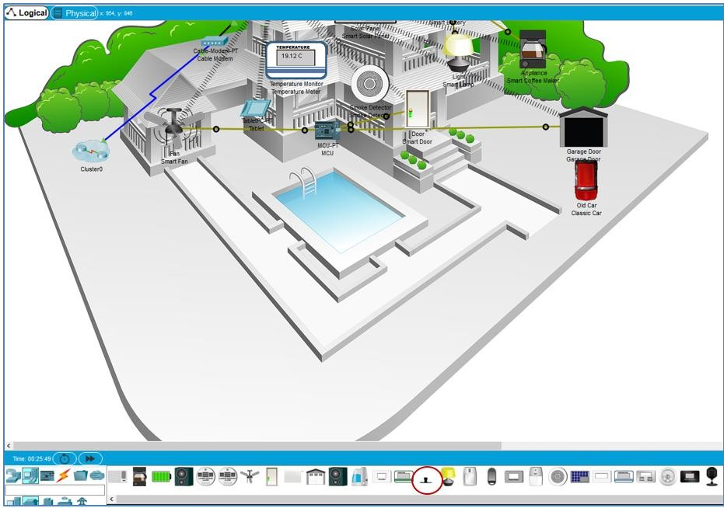

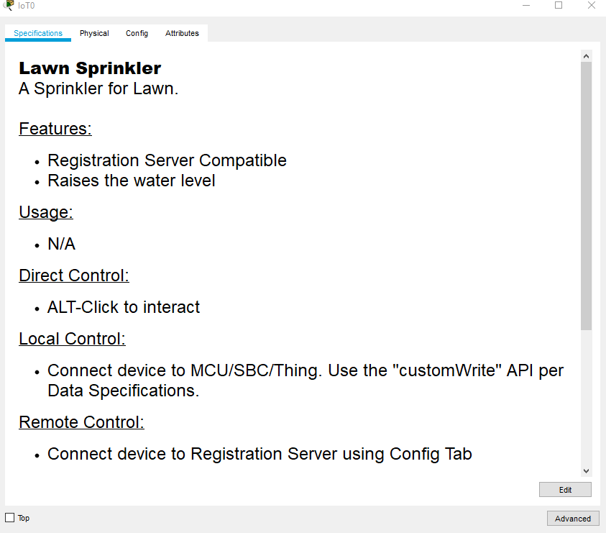

Click the Config tab to edit the device configuration settings. In the Config tab, make the following changes to Settings:

* + Set the **Display Name** to Sprinkler1 (notice the window name changes to Sprinkler1)
  + Set the IoT Server to Home Gateway

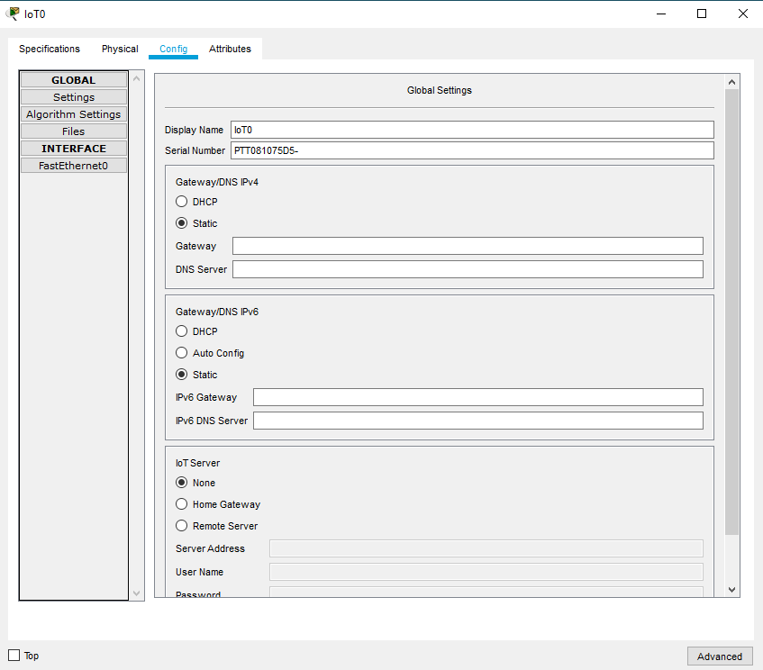

Click **FastEthernet0** and change the **IP Configuration** to **DHCP**.

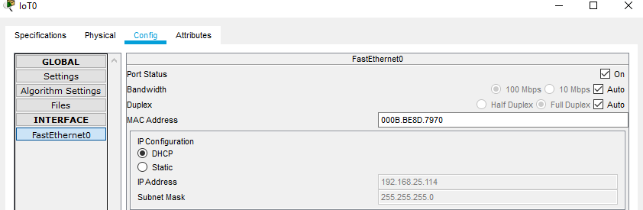

Close the **Sprinkler1** window.

* Verify that the sprinker is on the network.Log into the **Home Gateway** from the **Tablet.**

The device Sprinkler 1 should now appear in the IoT Server – Devices list.

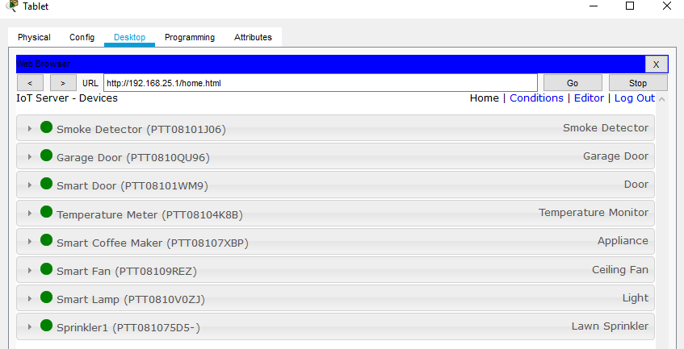

Close the Tablet window.

## Step 3: Experiment by adding other types of IoT devices to the smart home network.

**Part 3: Add Wireless IoT Devices to the Smart Home Network**

**Step 1: Add a wireless device to the network**

* In the **Device-Specific Selection** box click the **Wind Detector** icon and then click in the workspace where you would like to locate the **Wind Detector**.



* Add wireless module to the Wind Detector.

Change the **Network Adapter** drop down list to **PT-IOT-NM-1W**, which is a wireless adapter.

Click the **Wind Detector** icon in the workspace to open the IoT device window. In the bottom right corner of the IoT device window, click the **Advanced** button. Notice more tabs become visible at the top of the window. Click the **I/O Config** tab.

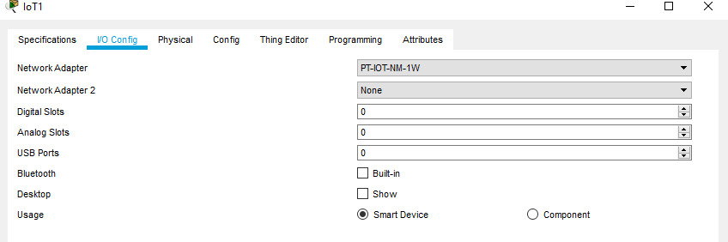

Configure the Wind Detector for the wireless network. Click the **Config** tab.

Change the **Display Name** to **Wind_Detector** and change the **IoT Server** to **Home Gateway**.

Next click **Wireless0** in the left pane. Change the Authentication type to **WPA2-PSK** and in the **PSK Pass Phrase** box type **mySecretKey.** These are the wireless settings from the Home Gateway that you recorded in Part 1.

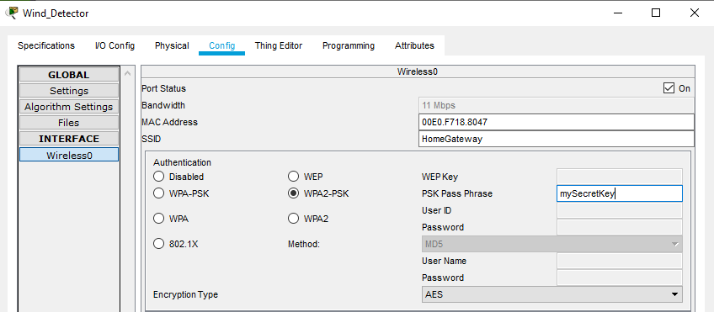

A wireless connection should be formed between the Wind Detector and the Home Gateway.

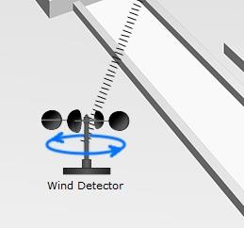

Verify the Wind Detector is on the network. Log into the Home Gateway from the Tablet**.**

The device Wind Detector should now appear in the **IoT Server – Devices** list.

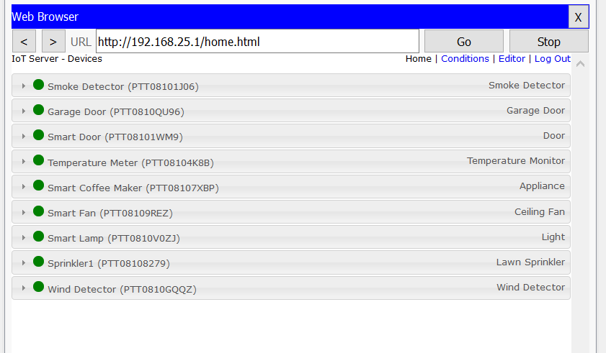

Close the Tablet window.

## Step 2: Experiment by adding other types of IoT devices to the smart home wireless network.

## Conclusion :

## ­­­­­­­­­­­­­­­­­­­­­